**Practical-3**

#### AIM: Allocating IP address to network topologies.

Student should be able to apply IP addresses to

1. Topology: two directly connected computers
2. Topology: four computers connected by switches
3. Topology: two networks connected by Router

Various networking commands:

* ping
* ipconfig
* arp –a
* netstat
* netbios
* tracert
* hostname
* nmap

Reference Videos

1. IP address: <https://www.youtube.com/watch?v=ykz4oUPWACw>
2. IP address assignment in Video: <https://www.youtube.com/watch?v=vcAtxgDsl00>
3. Classes of IPv4 address: <https://www.youtube.com/watch?v=VkgfyLf1raY>

Reference for commands:

1. <https://lizardsystems.com/articles/network-command-line-utilities/>
2. <https://www.youtube.com/watch?v=nH85pddWWAk>
3. <https://www.youtube.com/watch?v=rurs7cdT5cc&t=7s>

**Note:** While applying IP address, student needs to allocate IP address as per his/her student ID. For Example, if student ID is 22cs005 then IP address allocation for the first network should start with 5.0.0.0. For subsequent networks, it should start with ID+1 i.e. 6.0.0.0, 7.0.0.0 and so on.

**________________________________________________________________**

**Refer to the following scenarios and let’s understand What is an IP Address and Purpose of IP Address.**

**Scenario : 1**

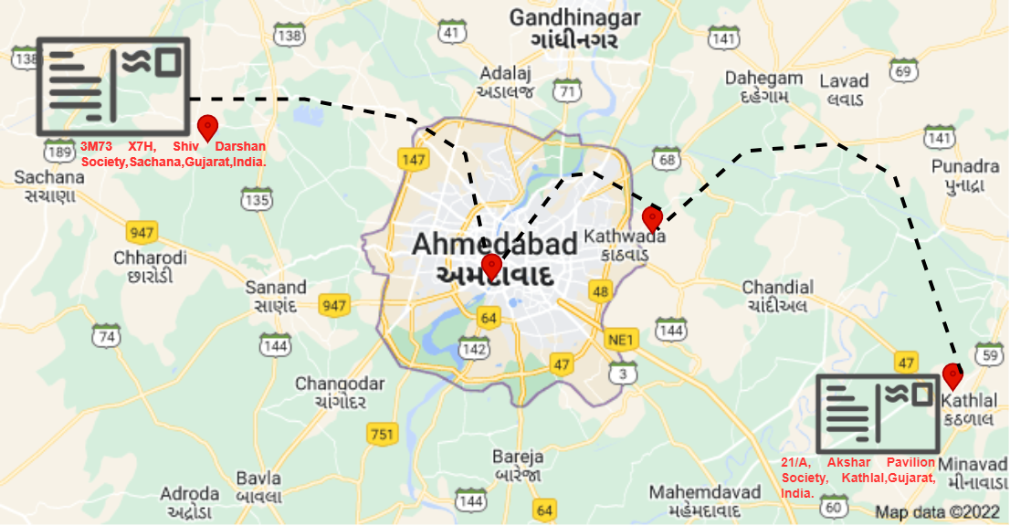

In this first scenario, an envelope is sent from sachana to kathlal. But there was some check point like ahmedabad, kathwada and then the envelope is delivered to kathlal.

Justify the following statement.

1. Was there any difficulty faced during sending the envelope from sender to receiver?

**Scenario : 2**

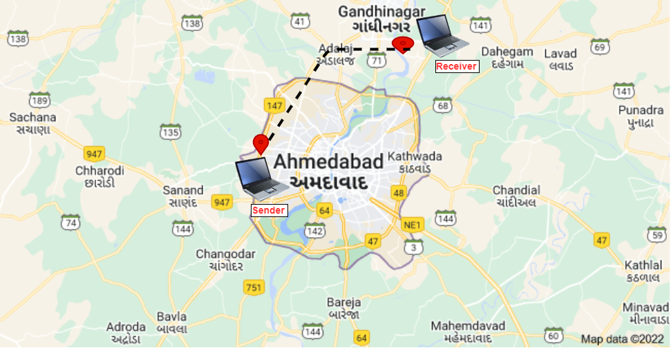

In this second scenario, the sender was located at Ahmedabad and wanted to send a file to the receiver who was located at Gandhinagar. But at the time of sending a file to the receiver, the receiver's machine was powered off. So, can the receiver receive the file from the sender or not?

Justify the following statement.

1. Was there any difficulty faced during sending the file from sender to receiver? If yes then what would be the solution for it.

**Scenario: 3**

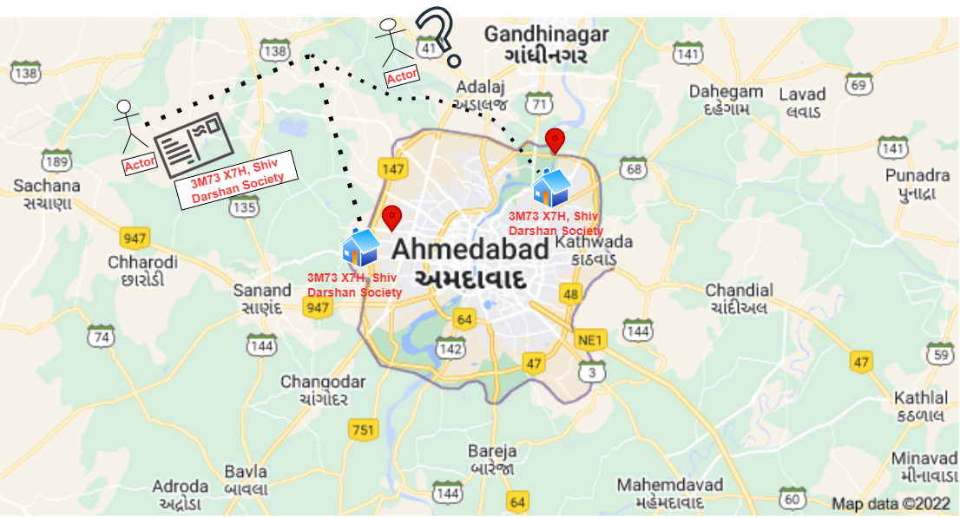

Refer the above image, and justify your answer

Question: Can the envelope be sent to the proper destination?

**Scenario: 4**

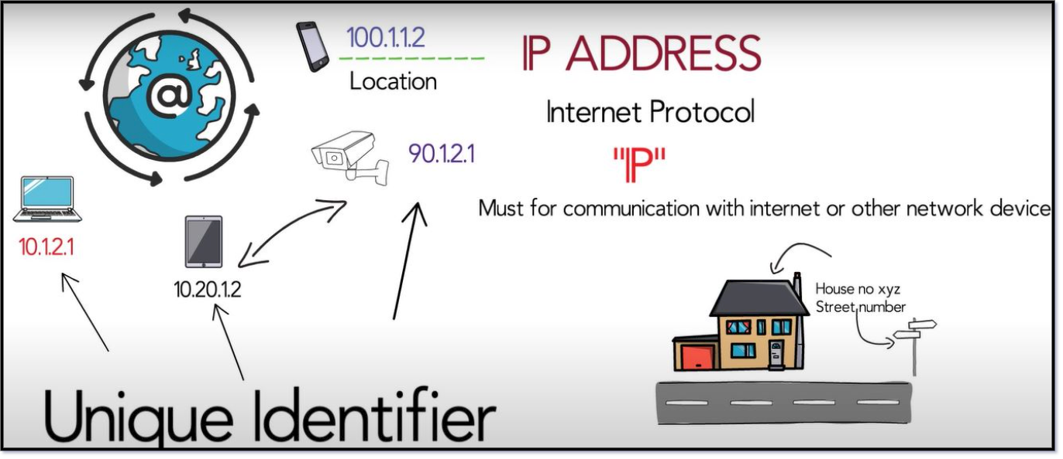

An IP address also acts like a return address on postal mail. When a letter you've mailed is delivered to the wrong address, you get the letter back if you include a return address on the envelope. The same holds true for email. When you write to an invalid recipient (such as someone who left their job and no longer has a company email address) your IP address lets the company’s mail server send you back a bounce message so that you know your email wasn't sent to the right place.

**From the above all scenarios, what would be the conclusion?**

**IP Address Types**

Basically, there are two primary types of ip address formats used today.

**1. IPv4**

**2. IPv6**

**Refer to the following diagrams and let’s understand IPv4 Address Representation**

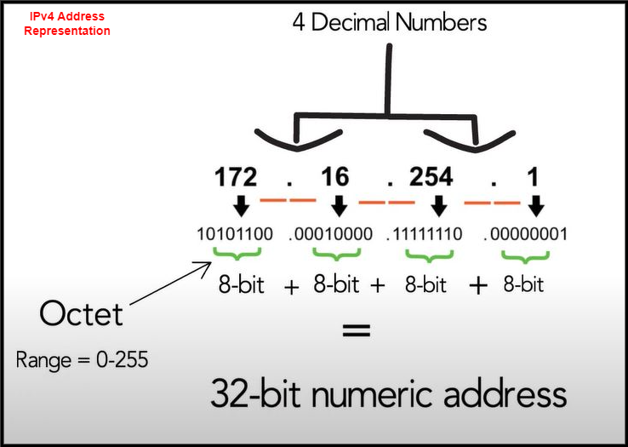

**Refer to the following case-study and let’s understand IPv4 Address Structure.**

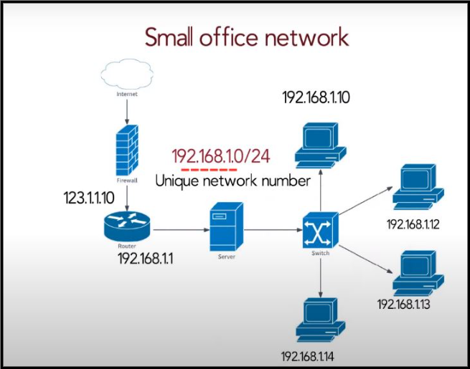

In this scenario, representing a small office network, each network running on TCP must have a unique number, and every machine on it must have a unique IP address. An IPv4 address is a 32-bit hierarchical address that is made up of a network portion and a host portion. When determining the network portion versus the host portion, you must look at the 32-bit stream. A subnet mask is used to determine the network and host portions.

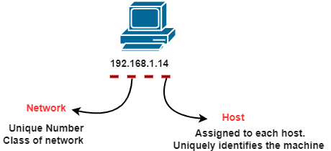

**IPv4 Address Structure**

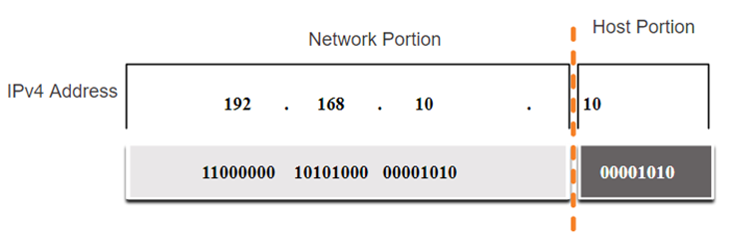

**IPv4 Address Structure using Binary format**

**IPv4 Address Structure : Subnet Mask**

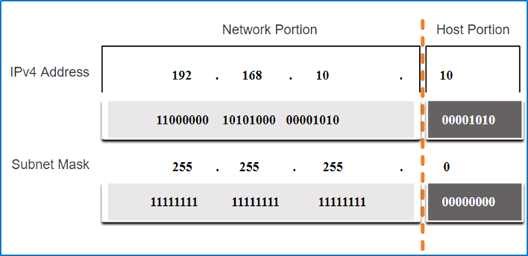

To identify the network and host portions of an IPv4 address, the subnet mask is compared to the IPv4 address bit by bit, from left to right. The actual process used to identify the network and host portions is called ANDing.

**IPv4 Address Structure: Prefix Length**

A prefix length is a less cumbersome method used to identify a subnet mask address. The prefix length is the number of bits set to 1 in the subnet mask. It is written in “slash notation” therefore, count the number of bits in the subnet mask and prepend it with a slash.

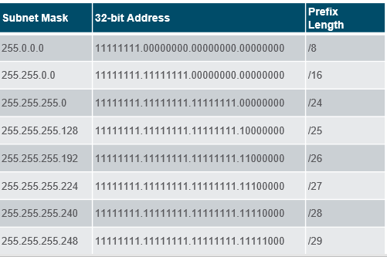

**Types of IPv4 Addresses: Legacy Classful Addressing**

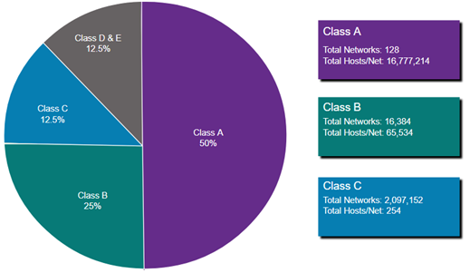

Classful addressing wasted many IPv4 addresses.

Classful address allocation was replaced with classless addressing which ignores the rules of classes (A, B, C).

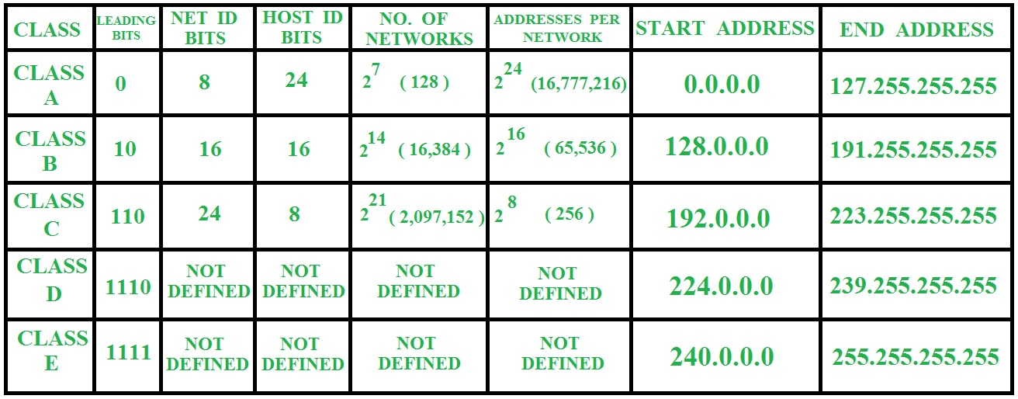

**Exercise-1**(Note: Start allocation IP address number from PC0)

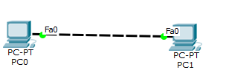

Redraw above diagram which includes IP address and MAC address. Take IP address and MAC address as per your knowledge. Insert image below.

* Ipconfig: fill table ipconfig of all computers

PC0

|  |  |
| --- | --- |
| **Parameter** | **Value** |
| Link local IPV6 Address | FE80 :: 202 : 4AFF : FE9A: D40B |
| IP address | 97.11.1.1 |
| Subnet Mask | 255.0.0.0 |
| Default Gateway | 0.0.0.0 |

PC1

|  |  |
| --- | --- |
| **Parameter** | **Value** |
| Link local IPV6 Address | FE80 :: 202 : 17FF : FE1B: 8265 |
| IP address | 97.11.1.2 |
| Subnet Mask | 255.0.0.0 |
| Default Gateway | 0.0.0.0 |

* Ipconfig /all: apply command on command prompt and write parameters and values in the following table.

PC0

|  |  |
| --- | --- |
| **Parameter** | **Value** |
| DHCP server | 0.0.0.0 |
| DHCPv6 IAID | - |
| DHCPv6 Client DUID | 00-01-00-01-5B-90-3C-5C-00-02-4A-9A-D4-0B |
| DNS Servers | 0.0.0.0 |

PC1

|  |  |
| --- | --- |
| **Parameter** | **Value** |
| DHCP server | 0.0.0.0 |
| DHCPv6 IAID | - |
| DHCPv6 Client DUID | 00-01-00-01-84-A1-A9-0A-00-02-17-1B-82-65 |
| DNS Servers | 0.0.0.0 |

* Arp –a: before ping, write output of command from PC0 and PC1 computers

PC0

|  |  |
| --- | --- |
| **Parameter** | **Value** |
| Internet Address | 97.11.1.2 |
| Physical Address | 0002. 171b. 8265 |
| Type | dynamic |

PC1

|  |  |
| --- | --- |
| **Parameter** | **Value** |
| Internet Address | 97.11.1.1 |
| Physical Address | 0002.4a9a.d40b |
| Type | dynamic |

* Ping from PC0 to PC1 and vice versa and insert snap of output here.

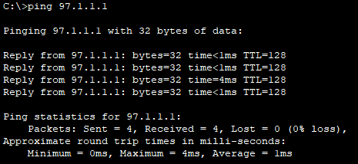

* Arp –a: after ping, insert snap (below) of output of command from all computers

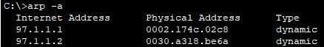

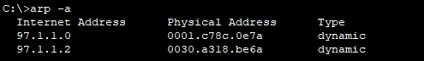

------------------------------------------------------------------------------------------------------------

**Exercise-2:** (Note: Start allocation IP address number from PC0)

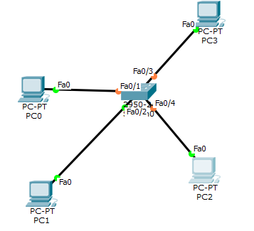

Redraw above diagram which includes IP address and MAC address. Take IP address and MAC address as per your instruction. Insert image below.

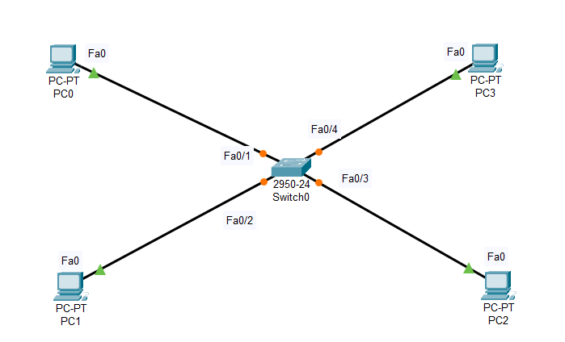

* Ipconfig: fill table ipconfig of all computers

PC0

|  |  |
| --- | --- |
| Link local IPV6 Address | FE80: :2D0 : FFFF : FEAD: 30B8 |
| IP address | 97.1.1.1 |
| Subnet Mask | 255.0.0.0 |
| Default Gateway | 0.0.0.0 |

PC1

|  |  |
| --- | --- |
| Link local IPV6 Address | FE80: :201 : 97FF : FE6A: CA3B |
| IP address | 97.1.1.2 |
| Subnet Mask | 255.0.0.0 |
| Default Gateway | 0.0.0.0 |

PC2

|  |  |
| --- | --- |
| Link local IPV6 Address | FE80: :2E0 : A3FF : FEED: 32E4 |
| IP address | 97.1.1.3 |
| Subnet Mask | 255.0.0.0 |
| Default Gateway | 0.0.0.0 |

PC3

|  |  |
| --- | --- |
| Link local IPV6 Address | FE80: :260 : 5CFF : FE89: 8E8C |
| IP address | 97.1.1.4 |
| Subnet Mask | 255.0.0.0 |
| Default Gateway | 0.0.0.0 |

* Ipconfig /all: apply command on command prompt and write parameters and values in following table.

PC0

|  |  |
| --- | --- |
| **Parameter** | **Value** |
| DHCP server | 0.0.0.0 |
| DHCPv6 IAID | - |
| DHCPv6 Client DUID | 00-01-00-01-9C-B1-AD-D1-00-DO-FF-AD-30-B8 |
| DNS Servers | 0.0.0.0 |

PC1

|  |  |
| --- | --- |
| **Parameter** | **Value** |
| DHCP server | 0.0.0.0 |
| DHCPv6 IAID | - |
| DHCPv6 Client DUID | 00-01-00-01-5B-90-3C-5C-00-02-4A-6A-C4-3B |
| DNS Servers | 0.0.0.0 |

PC2

|  |  |
| --- | --- |
| **Parameter** | **Value** |
| DHCP server | 0.0.0.0 |
| DHCPv6 IAID | - |
| DHCPv6 Client DUID | 00-01-00-01-5B-90-3C-5C-00-02-A3-ED-32-E4 |
| DNS Servers | 0.0.0.0 |

PC3

|  |  |
| --- | --- |
| **Parameter** | **Value** |
| DHCP server | 0.0.0.0 |
| DHCPv6 IAID | - |
| DHCPv6 Client DUID | 00-01-00-01-B0-D8-CB-5C-00-02-4A-89-8E-BC |
| DNS Servers | 0.0.0.0 |

* Arp –a: before ping write/snap of output of command from all computers



* Ping from PC0 to PC1 and vice versa and get the output here.



* Arp –a: after ping write/snap of output of command from all computers
* PC0



* PC1



* PC2

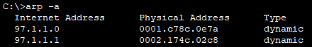

* PC3



* Netstat: write/snap of output of command from all computers

PC0

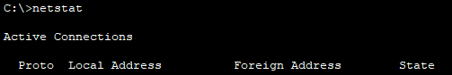

PC1

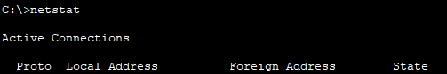

PC2

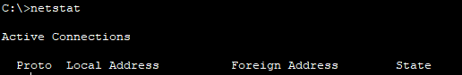

PC3



* show ip route: write/snap of output of command from all computers



Same output for all computer

----------------------------------------------------------------------------------------------------------------

**Exercise-3** (Note: Start allocation IP address number from PC0)

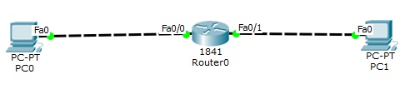

Redraw above diagram which includes IP address and MAC address. Take IP address and MAC address as per your instruction. Insert image below.

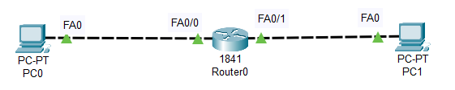

* Ipconfig: fill following table with output of ipconfig of computer.

PC0

|  |  |
| --- | --- |
| Link local IPV6 Address | FE80::2E0:A3FF:FE9D:597D |
| IP address | 97.1.1.2 |
| Subnet Mask | 255.0.0.0 |
| Default Gateway | 97.1.1.1 |

PC1

|  |  |
| --- | --- |
| **Parameter** | **Value** |
| Link local IPV6 Address | FE80::210:11FF:FE59:D76B |
| IP address | 23.1.1.2 |
| Subnet Mask | 255.0.0.0 |
| Default Gateway | 23.1.1.1 |

* Ipconfig /all: apply command on command prompt and write parameters and values in following table

PC0

|  |  |
| --- | --- |
| **Parameter** | **Value** |
| DHCP server | 0.0.0.0 |
| DHCPv6 IAID | - |
| DHCPv6 Client DUID | 00-01-00-01-E9-43-1C-05-00-E0-A3-9D-59-7D |
| DNS Servers | 0.0.0.0 |

PC1

|  |  |
| --- | --- |
| **Parameter** | **Value** |
| DHCP server | 0.0.0.0 |
| DHCPv6 IAID | - |
| DHCPv6 Client DUID | 00-01-00-01-DD-04-05-B1-00-10-11-59-D7-6B |
| DNS Servers | 0.0.0.0 |

* Arp –a: before ping write/snap of output of command from all computers



* Ping from PC0 to PC1 and vice versa and get the output here.

PC0 – PC1

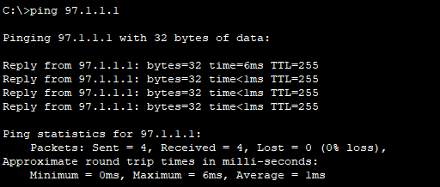

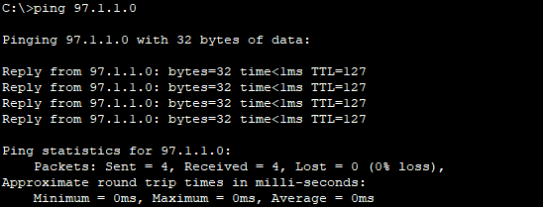

* Arp –a: after ping write/snap of output of command from all computers

PC0



PC1



* Netstat: write/snap of output of command from all computers

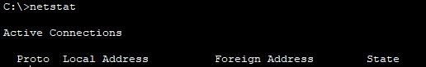

Same for all computers

* show ip route: write/snap of output of command from all computers



Same for all computers